

***CSE 101 COMPUTER PROGRAMMING***

**FINAL REPORT**

ON

**ICE CREAM PARLOR MANAGEMENT SYSTEM**

**Section: K22BH**

Under the guidance of

**JASPREET KAUR MAM : 27403**

**Group Members Details:**

|  |  |  |  |
| --- | --- | --- | --- |
| **S No.** | **Roll No.** | **Name** | **Reg No.** |
| **1.** | **37** | **Parvati** | **12215266** |
| **2.** | **38** | **Nishant Kumar** | **12214304** |
| **3.** | **39** | **Abhishek Kumar** | **12215014** |
| **4.** | **40** | **Vishal Singh** | **12215059** |

**Discipline of CSE/IT**

**Lovely School of Computer Science & Engineering**

**Lovely Professional University, Phagwara**

***CONTENTS***

|  |  |  |
| --- | --- | --- |
| **No.** | **Title** |  |
| 1 | Project Description |  |
| 2 | Programming Code |  |
| 3 | Module Explanation  1st module  2nd module  3rd module  4th module  5th module |  |
| 4 | Snapshot of Code |  |
| 5 | Output of the Code |  |
| 6 | DFD (level 0) |  |
| 7 | Conclusion |  |

***PRJECT DESCRIPTION***

**Ice-Cream Parlor Management system**

An ice cream parlor management system using C code with modules for adding, deleting, searching, updating, and displaying information would be a software application designed to manage the operations of an ice cream parlor.

Each module would perform a specific function:

1. DISPLAY ICE CREAM LIST
2. ADD NEW ICE CREAM
3. UPDATE THE RECORD OF THE ICE CREAM
4. SEARCH ANY ICE CREAM
5. DELETE ANY ICE CREAM RECORD

* The add module would allow the user to input information for new ice cream flavours, toppings, or ingredients into the system.
* The delete module would allow the user to remove any unwanted or expired items from the inventory.
* The search module would allow the user to search for specific items in the inventory, such as a particular flavour of ice cream.
* The update module would allow the user to modify the information for an existing item in the inventory, such as changing the price or updating the stock level.
* The display module would allow the user to view the current inventory, including the available flavour’s, toppings, and ingredients, along with their respective prices and stock levels.

Together, these modules would provide a comprehensive solution for managing an ice cream parlor's inventory and operations efficiently. Additionally, the C code could be used to integrate other features, such as employee management, reporting, and analytics, to further optimize the parlor's performance.

*C PROGRAMMING CODE*

#include <stdio.h>

#include <stdlib.h>

struct ice_cream {

int id;

char name[50];

int price;

int stock;

};

void display_menu();

void add_ice_cream();

void update_ice_cream();

void search_ice_cream();

void delete_ice_cream();

int main() {

int choice;

do {

display_menu();

scanf("%d", &choice);

switch(choice) {

case 1:

display_ice_creamlist();

break;

case 2:

add_ice_cream();

break;

case 3:

update_ice_cream();

break;

case 4:

search_ice_cream();

break;

case 5:

delete_ice_cream();

break;

case 6:

printf("Exiting program...\n");

exit(0);

break;

default:

printf("Invalid choice. Please try again.\n");

}

} while(choice != 6);

return 0;

}

void display_menu() {

printf("\n\n Ice Cream Management System\n");

printf("l. List of ice cream\n");

printf("2. Add ice cream\n");

printf("3. Update ice cream\n");

printf("4. Search ice cream\n");

printf("5. Delete ice cream\n");

printf("6. Exit\n");

printf("Enter your choice: ");

}

void display_ice_creamlist(){

FILE *fp;

struct ice_cream ic;

fp=fopen("ice_creams.dat","r");

printf("\t\t\t\t======= ICE CREAM RECORD =======\n\n\n");

if(fp==NULL){

fprintf(stderr,"can't open file\n");

exit(0);

}else{

printf("\t\t\t\tRECORDS :\n");

printf("\t\t\t\t___________\n\n");

}

while(fread(&ic, sizeof(ic), 1, fp)){

printf("\n\t\t\t\t ID : %d",ic.id);

printf("\n\t\t\t\t Name : %s",ic.name);

printf("\n\t\t\t\t Price : %d",ic.price);

printf("\n\t\t\t\t Stock : %d",ic.stock);

printf("\n\t\t\t\t ________________________________\n");

}

fclose(fp);

getch();

}

void add_ice_cream() {

struct ice_cream ic;

FILE *fp;

fp = fopen("ice_creams.dat", "ab");

printf("\nEnter ice cream details:\n");

printf("ID: ");

scanf("%d", &ic.id);

printf("Name: ");

scanf("%s", &ic.name);

printf("Price: ");

scanf("%d", &ic.price);

printf("Stock: ");

scanf("%d", &ic.stock);

fwrite(&ic, sizeof(ic), 1, fp);

fclose(fp);

printf("Ice cream added successfully.\n");

}

void update_ice_cream() {

int id;

struct ice_cream ic;

FILE *fp;

fp = fopen("ice_creams.dat", "rb+");

printf("\nEnter ID of ice cream to update: ");

scanf("%d", &id);

while(fread(&ic, sizeof(ic), 1, fp)) {

if(ic.id == id) {

printf("\nEnter new details for ice cream:\n");

printf("ID: ");

scanf("%d", &ic.id);

printf("Name: ");

scanf("%s", &ic.name);

printf("Price: ");

scanf("%d", &ic.price);

printf("Stock: ");

scanf("%d", &ic.stock);

fseek(fp, -(long)sizeof(ic), SEEK_CUR);

fwrite(&ic, sizeof(ic), 1, fp);

fclose(fp);

printf("Ice cream updated successfully.\n");

return;

}

}

fclose(fp);

printf("Ice cream not found.\n");

}

void search_ice_cream() {

int id;

struct ice_cream ic;

FILE *fp;

fp = fopen("ice_creams.dat", "r");

printf("\nEnter ID of ice cream to search: ");

scanf("%d", &id);

while(fread(&ic, sizeof(ic), 1, fp)) {

if(ic.id == id) {

printf("\nID: %d\n", ic.id);

printf("Name: %s\n", ic.name);

printf("Price: %d\n", ic.price);

}

}

fclose(fp);

}

void delete_ice_cream() {

int id,count=0;

struct ice_cream ic;

FILE *fp, *temp_fp;

fp = fopen("ice_creams.dat", "r");

temp_fp = fopen("temp.dat", "w");

if (fp == NULL) {

printf("Error opening file.\n");

return;

}

printf("Enter ID of ice cream to delete: ");

scanf("%d", &id);

while (fread(&ic, sizeof(ic), 1, fp)) {

if (ic.id == id) {

count=1; // skip the record we want to delete

}

else{

fwrite(&ic, sizeof(ic), 1, temp_fp);

}

}

fclose(fp);

fclose(temp_fp);

if(!count){

printf("\nrecord not found");

}

if(count){

remove("ice_creams.dat");

rename("temp.dat", "ice_creams.dat");

printf("Ice cream record deleted successfully.\n");

}

}

***MODULE EXPLANATION***

***MODULE 1 : DISPLAY ICE CREAM LIST***

The C code function called "display_ice_creamlist" that reads a binary file named "ice_creams.dat" and displays the contents of the file on the console.

The function first declares a file pointer variable "fp" and an ice_cream structure variable "ic". It then opens the file "ice_creams.dat" in read mode using the "fopen()" function.

The function checks whether the file was opened successfully or not. If the file could not be opened, the function prints an error message on the console and terminates the program using the "exit()" function. If the file was opened successfully, the function displays a header message on the console.

The function then reads the binary file using the "fread()" function and stores the contents in the "ic" variable. It then displays the contents of the "ic" variable on the console using the "printf()" function. This process is repeated until the end of the file is reached.

Finally, the function closes the file using the "fclose()" function and waits for a key press using the "getch()" function.

Note: The implementation of the "ice_cream" structure is not provided in the code snippet, so it is unclear what data the structure contains

***MODULE 2 : ADD NEW ICE CREAM***

The C CODE function called "add_ice_cream" that allows the user to add a new ice cream record to a binary file named "ice_creams.dat".

The function first declares an ice_cream structure variable "ic" and a file pointer variable "fp". It then opens the file "ice_creams.dat" in append binary mode using the "fopen()" function and assigns the file pointer to the "fp" variable.

The function then prompts the user to enter the details of the new ice cream record, such as ID, name, price, and stock, using the "printf()" and "scanf()" functions.

After the user enters the details, the function writes the contents of the "ic" variable to the file using the "fwrite()" function. The "fwrite()" function writes the binary representation of the "ic" variable to the file.

Finally, the function closes the file using the "fclose()" function.

Note: The implementation of the "ice_cream" structure is not provided in the code snippet, so it is unclear what data the structure contains.

***MODULE 3 : UPDATE THE RECORD OF THE ICE CREAM***

This is a function written in C that updates the details of an ice cream in a binary file called "ice_creams.dat". The function takes no arguments and returns no value. Here's a breakdown of how it works:

1. It declares a variable **id** to store the ID of the ice cream to update, and a struct **ice_cream** to store the ice cream's details.
2. It opens the file "ice_creams.dat" in binary read-write mode (**"rb+"**) using **fopen()** and stores the file pointer in **fp**.
3. It prompts the user to enter the ID of the ice cream to update using **printf()** and **scanf()**.
4. It reads each ice cream record from the file using **fread()** and stores it in the **ic** struct until the end of the file is reached.
5. For each record, it checks if the ID of the current ice cream matches the ID entered by the user.
6. If a match is found, it prompts the user to enter the new details of the ice cream using **printf()** and **scanf()**.
7. It uses **fseek()** to move the file pointer back to the beginning of the current record, and then uses **fwrite()** to overwrite the old record with the new one.
8. It closes the file using **fclose()**, prints a success message using **printf()**, and returns from the function.
9. If no match is found, it closes the file using **fclose()** and prints a failure message using **printf()**

***MODULE 4 : SEARCH ICE CREAM***

This is a function written in C that searches for an ice cream in a binary file called "ice_creams.dat" and prints its details. The function takes no arguments and returns no value. Here's a breakdown of how it works:

1. It declares a variable **id** to store the ID of the ice cream to search for, and a struct **ice_cream** to store the ice cream's details.
2. It opens the file "ice_creams.dat" in binary read mode (**"r"**) using **fopen()** and stores the file pointer in **fp**.
3. It prompts the user to enter the ID of the ice cream to search for using **printf()** and **scanf()**.
4. It reads each ice cream record from the file using **fread()** and stores it in the **ic** struct until the end of the file is reached.
5. For each record, it checks if the ID of the current ice cream matches the ID entered by the user.
6. If a match is found, it prints the details of the ice cream using **printf()**.
7. It continues to read through the rest of the file until the end is reached.
8. It closes the file using **fclose()**.

***MODULE 5 : DELETE ICE CREAM RECORD***

This is a C program that deletes a record of an ice cream from a file named "ice_creams.dat". It works by creating a temporary file called "temp.dat", reading each record from the original file and writing all the records except the one to be deleted to the temporary file. Then, it removes the original file and renames the temporary file to the original filename.

Note: This code assumes that the **struct ice_cream** has a member named **id** that contains the unique identifier for each ice cream record. It also assumes that the file "ice_creams.dat" exists and contains ice cream records in binary format.

***SNAPSHOTS OF CODE***

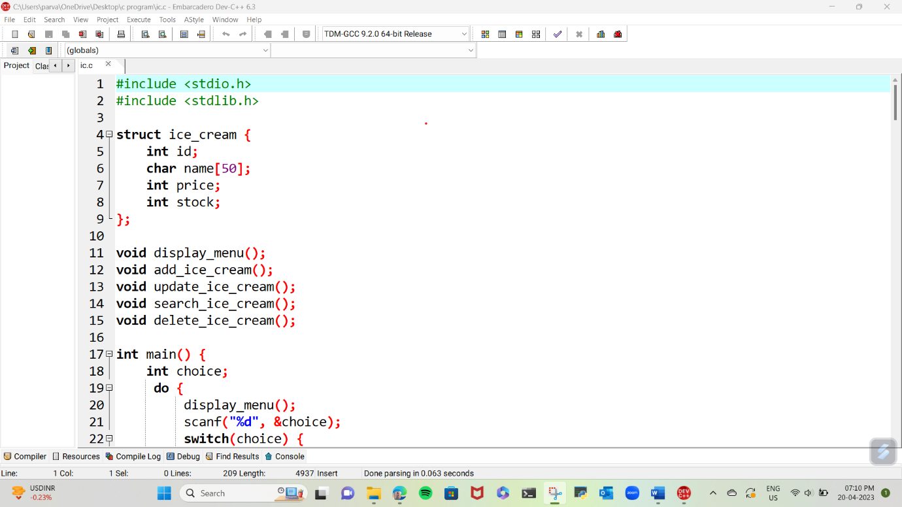

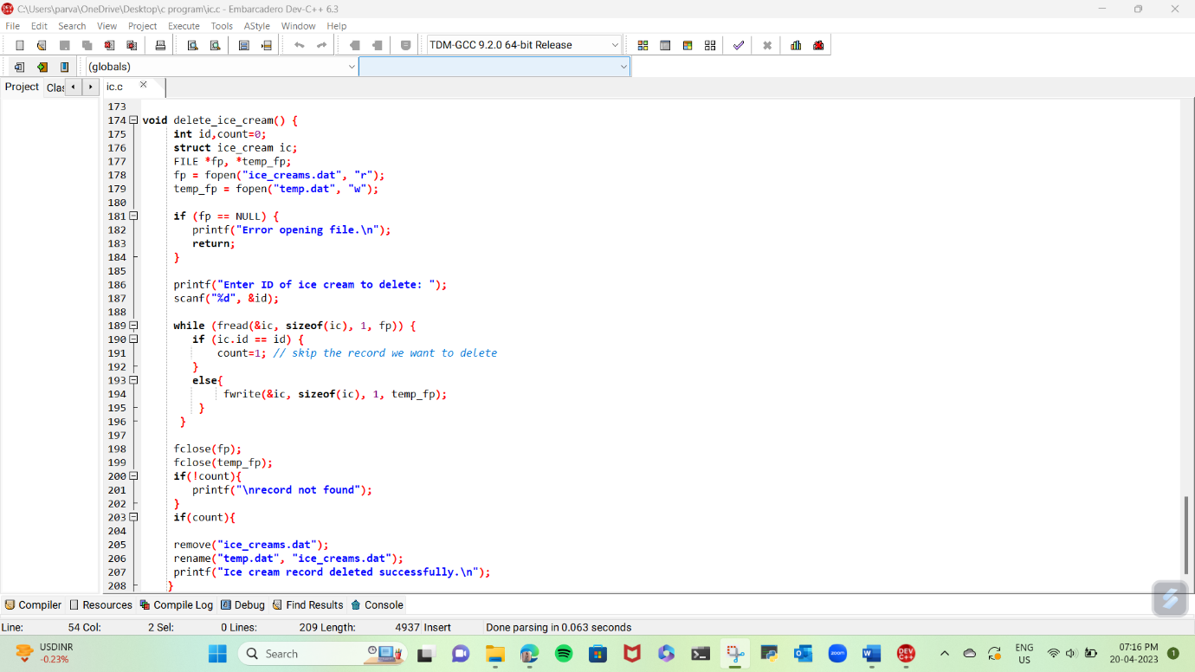

***OUTPUT OF CODE***

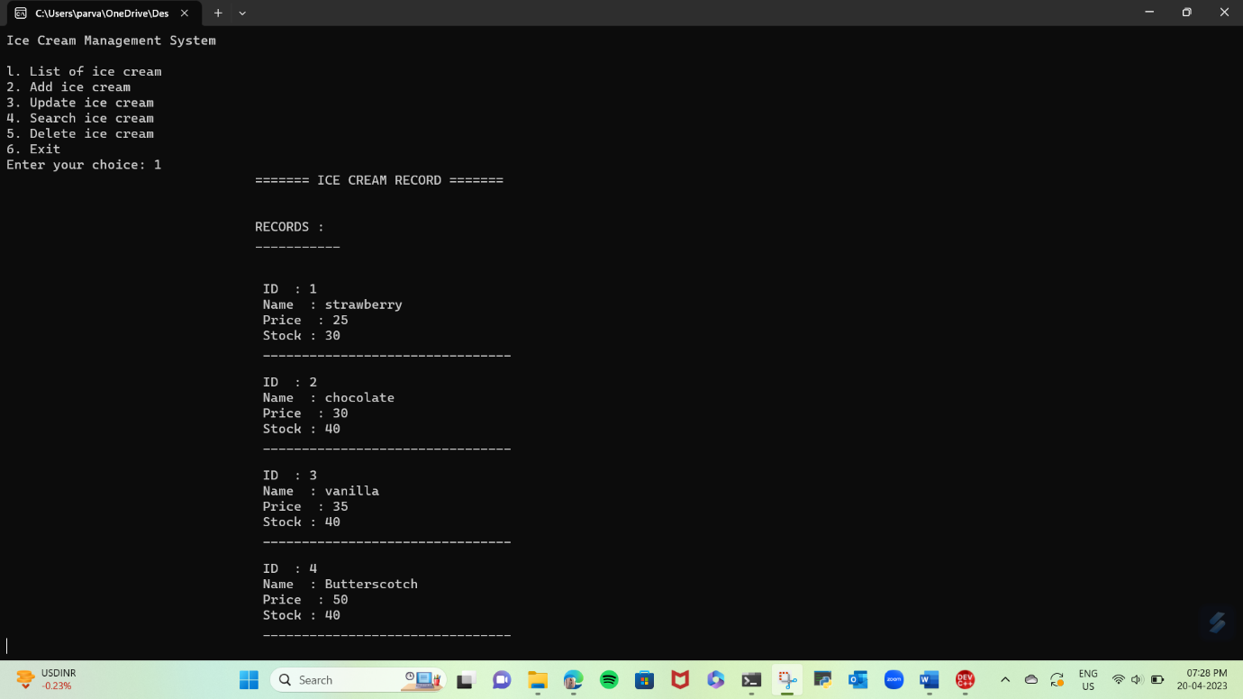

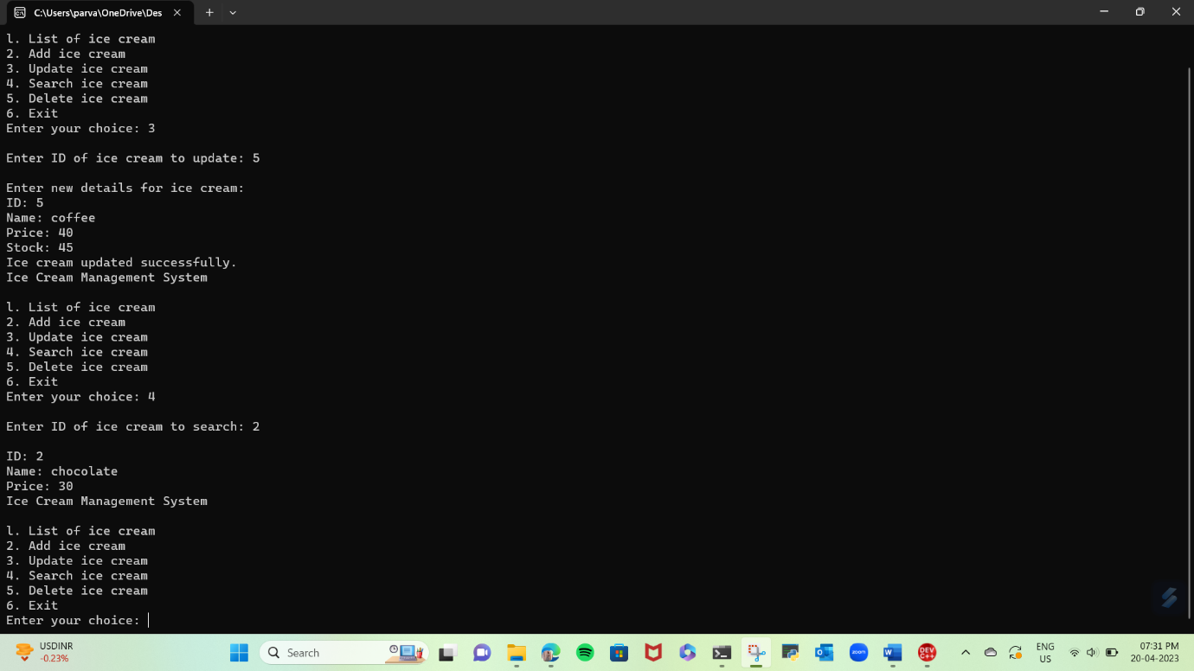

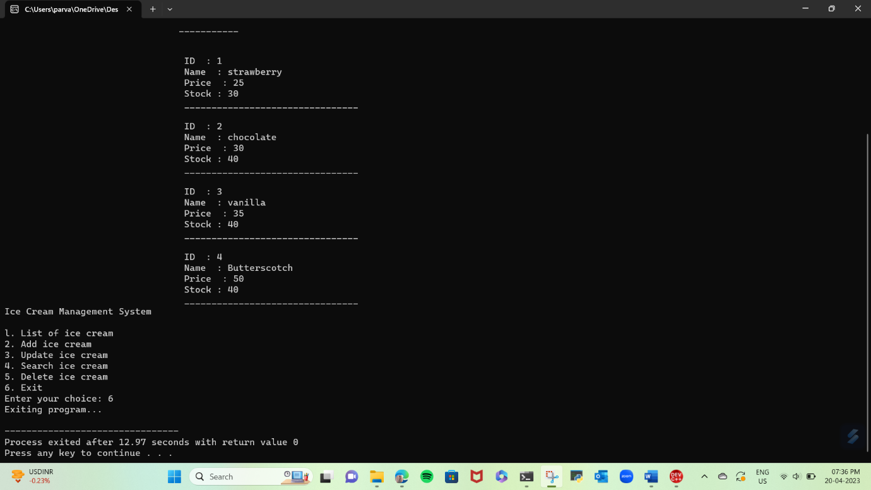

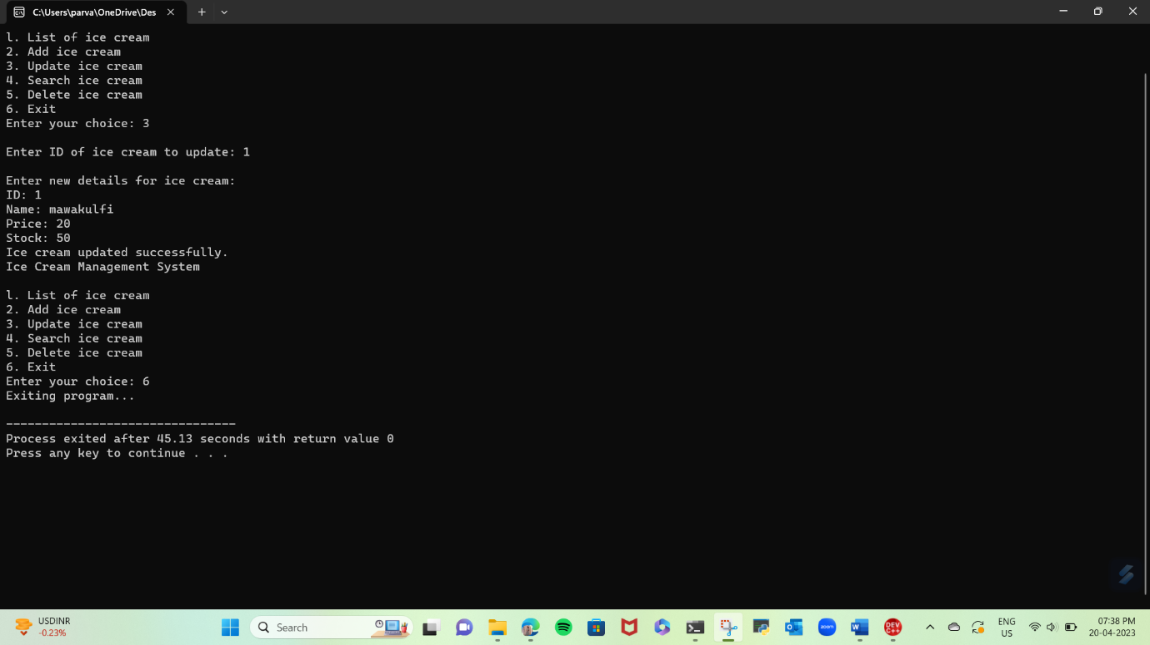

***DFD (0 LEVEL)***

**Ice Cream Management System**

**USER**

***CONCLUSION***

The program allows the user to add, delete, update, search for, and display ice cream items stored in a binary file. These functions provide basic functionality for managing inventory data, but there may be limitations in terms of the scalability, performance, and security of the system.

Additionally, it is unclear whether this program provides any user interface or other features that would make it usable for real-world applications. Further development and testing would be required to ensure the program is reliable, efficient, and user-friendly.

In summary, while this system may be useful for a small-scale ice cream parlor, it would likely require significant additional development to be used effectively in a larger-scale, real-world environment.